Milestone 1 — Project Definition & Architecture Plan
Business Account Data Enrichment Pipeline — Client Pilot, Athens, Georgia Mourya Bekkanur Dinesh — Sole Contributor

1. Business Problem and Primary User
The Client operates a business accreditation program and maintains a registry of accredited and accreditation-eligible businesses. Their Athens, Georgia pilot cohort contains approximately 50 business accounts, each with up to 14 required fields: business name, phone, email, website, address, city, state, zip, entity type, date established, principal name, principal title, number of employees, and business description. The majority of these fields are blank or unreliable across the cohort.
The workflow as it runs today, step by step:
- A data analyst opens a business account record manually.
- The analyst searches the Client's internal business profile database for available fields.
- For missing fields, the analyst searches Google, the Georgia Secretary of State (SOS) website, and the business's own website by hand.
- The analyst copies values into the account record manually, applying no consistency checks.
- The completed record is passed to the UMAP vetting team for downstream scoring.
- The vetting team flags incomplete or suspect records back to the analyst for correction.
This process takes 15 to 30 minutes per account and produces inconsistent results: different analysts apply different standards, source citations are absent, and there is no audit trail for how a value was derived. At 50 accounts the manual load is manageable, but the Client expects the pipeline to scale to hundreds of accounts.
Primary user: The data analyst who reviews and approves enriched field candidates before they are written to the account record. The analyst needs to see the proposed value, its source, a confidence score, and the evidence excerpt that supports it — enough to approve or reject in under 30 seconds per field.
Measurable outcome: Field completeness rate across all 14 required fields, measured before and after one full pipeline run on the 50-account Athens cohort. Target: 80% or more of accounts have all 14 fields populated at or above the confidence threshold after one run, compared against the before-enrichment baseline. Secondary metric: analyst review time per account, measured from review queue open to final approval decision.

2. Why AI, and Why This Design
Why AI is appropriate. The enrichment task requires reading unstructured text — business websites, SOS registry pages, web search snippets — and mapping it to structured fields. This is a natural language understanding problem: the evidence is present but not labeled, and the mapping requires reading comprehension rather than pattern matching. A rule-based system cannot reliably extract a principal name from an about page or distinguish a mailing address from a service area description. A large language model (Claude) handles this well and can return structured JSON with per-field confidence scores and evidence quotes.
Which steps need a model:
- Website candidate scoring: Claude scores up to 5 candidate URLs for name match, address signals, source trust, and domain hygiene.
- Pass A extraction: Claude reads fetched page content and extracts phone, email, principal name, principal title, business description, and employee count.
- Pass B extraction: Claude reads SOS registry data and profile data to fill fields still missing after Pass A.
- Web consensus pass: Claude reads 3 web search snippets per missing field and returns a consensus value with boosted confidence if 2 or more snippets agree.
Which steps stay deterministic:
- Georgia SOS eCorp lookup: a structured HTTP query to a government registry. The result is authoritative and must not be overridden by a model. Entity type and date established are locked once found.
- Confidence gate: a numerical threshold comparison. No model involved.
- Field write: a database update. Deterministic.
- Duplicate event detection: a database query on run_id. Deterministic.
- Timeout and escalation: a timestamp comparison. Deterministic.
Stakes and oversight. The enriched data feeds the UMAP vetting process. A wrong entity type or a fabricated principal name could cause a legitimate business to fail vetting or an ineligible one to pass. The stakes are moderate but the errors are not easily caught downstream. This implies two oversight controls: first, legal fields (entity type and date established) are locked from the SOS result and cannot be overwritten by any model call; second, all fields below the confidence threshold are held in a review queue and require explicit analyst approval before being written to the account record.

3. Target Workflow
The workflow runs as a fixed sequence per account. Figure 3.1 shows the full flow from input to output. The table below describes each step.
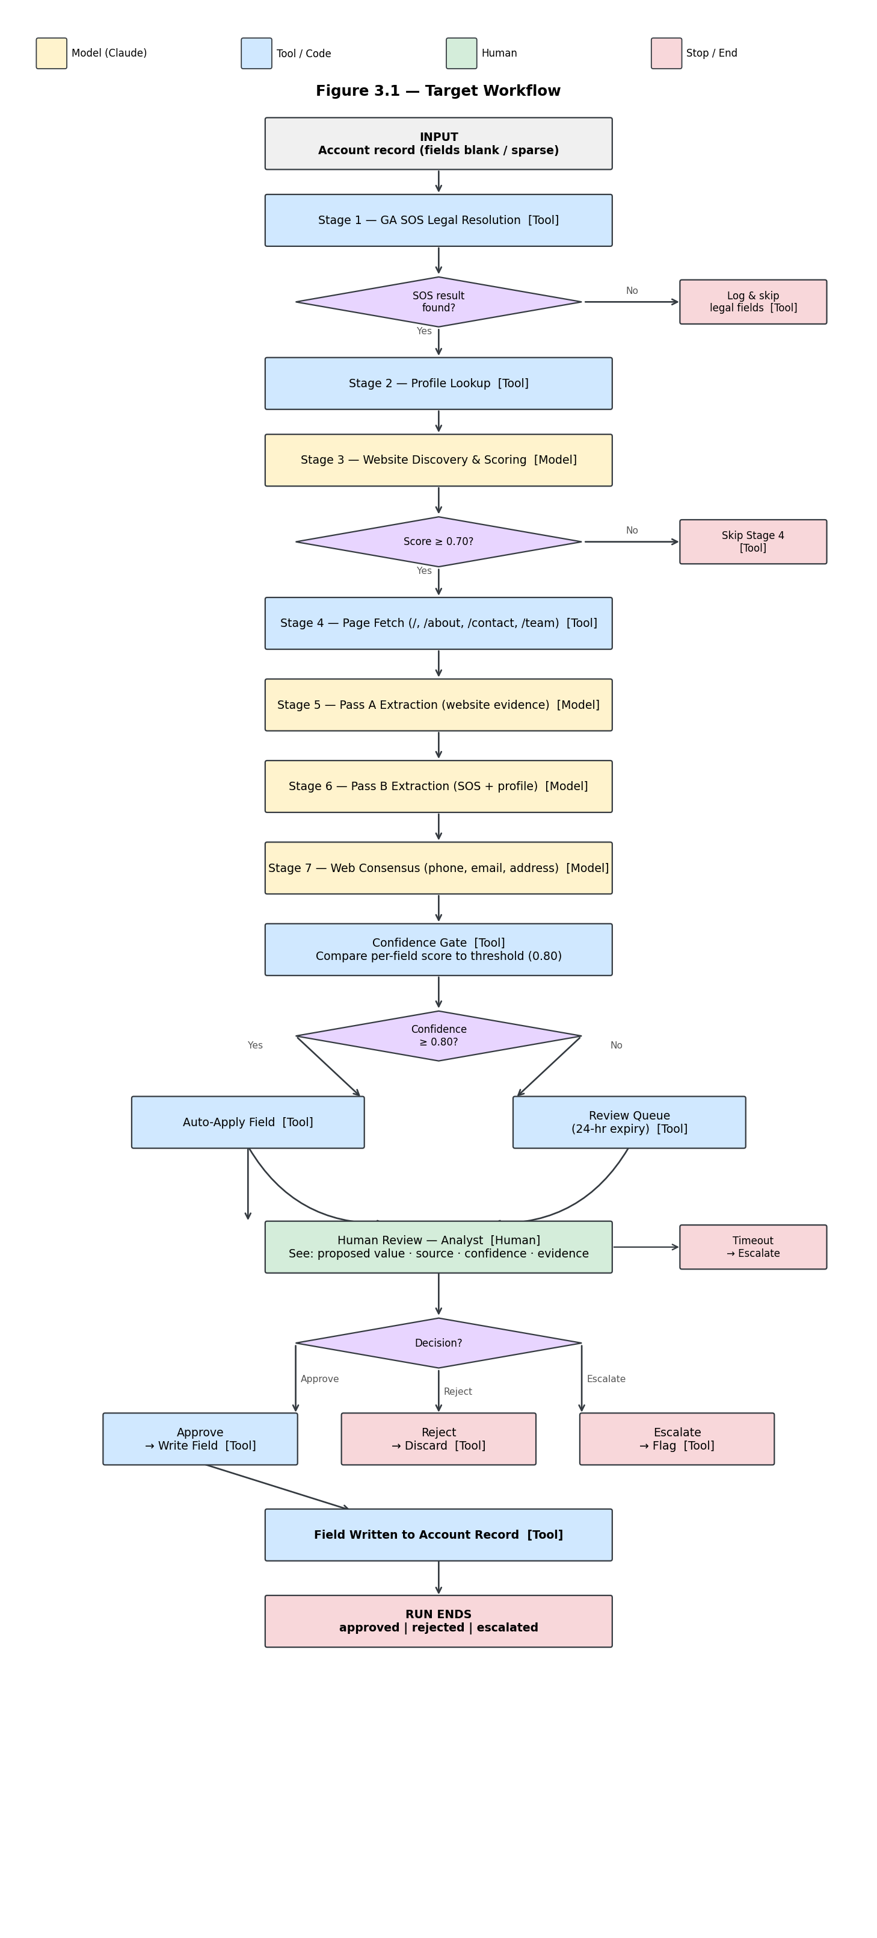
Figure 3.1. Target workflow — each step labeled Model / Tool / Human. Amber = Claude call; blue = deterministic tool; green = human; red = stop condition.
Step | Label | Action | Branch or stop condition
1. SOS legal resolution | Tool | HTTP query to GA SOS eCorp for entity type and date established | If found: lock fields, continue. If unavailable: log, skip, continue without legal fields
2. Profile lookup | Tool | Query Client profile data for available fields | Always continues
3. Website discovery gate | Model | Claude scores up to 5 candidate URLs 0.0 to 1.0 | Score >= 0.70: accept, continue to Stage 4. No qualifying URL: skip Stage 4, continue
4. Page fetch | Tool | Fetch home, about, contact, team pages; convert to markdown evidence | Fetch failure: log, continue with empty evidence
5. Pass A extraction | Model | Claude extracts 6 fields from page evidence only | Null = not found; never invents
6. Pass B extraction | Model | Claude extracts remaining fields from SOS and profile data | Null = not found; never invents
7. Web consensus | Model | Claude reads 3 web snippets per missing field; boosts confidence if 2+ agree | Only targets phone, email, address
8. Confidence gate | Tool | Compare confidence score to threshold | >= threshold: auto-apply. < threshold: route to review queue
9. Human review | Human | Analyst sees proposed value, source, confidence, evidence excerpt | Approve: write field. Reject: discard. Escalate: flag for supervisor. Timeout: escalate
10. Field write | Tool | Write approved value to account record | Run ends as approved, rejected, or escalated

4. Architecture Plan
Figure 4.1 shows the component architecture. The table below describes each component.
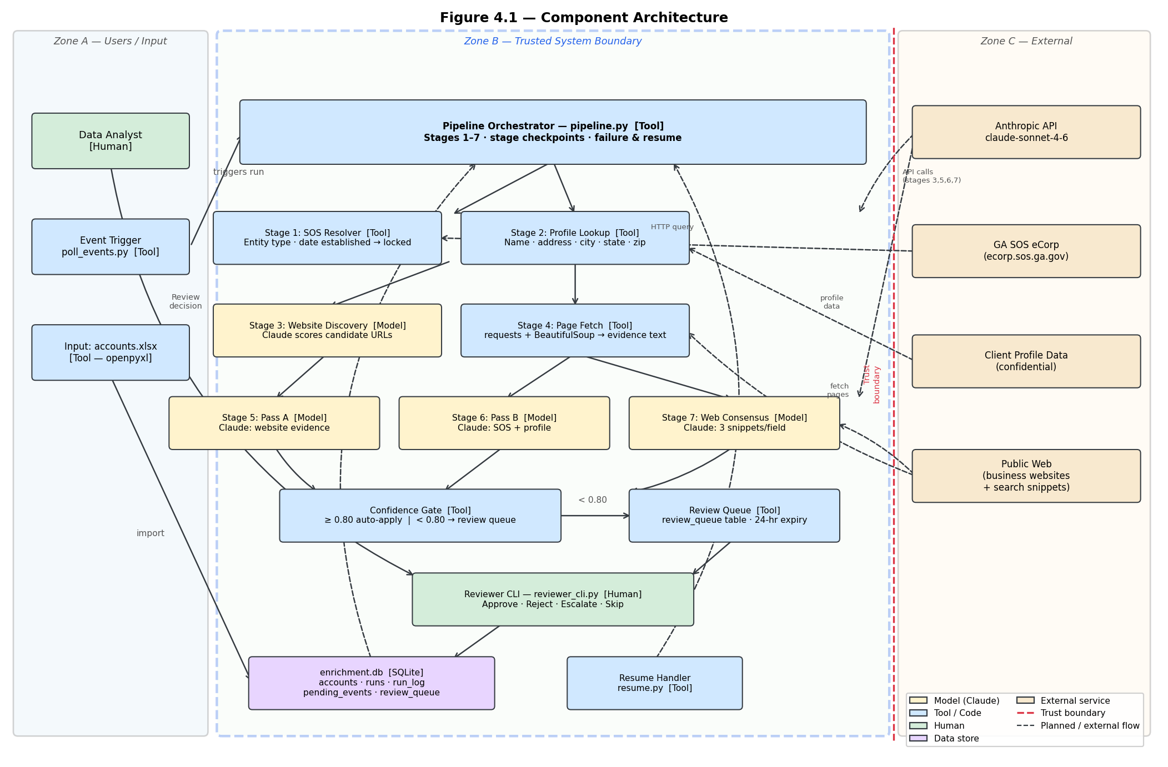
Figure 4.1. Component architecture. Zone A: users. Zone B: trusted system boundary (dashed blue). Zone C: external services. Red dashed line = trust boundary.
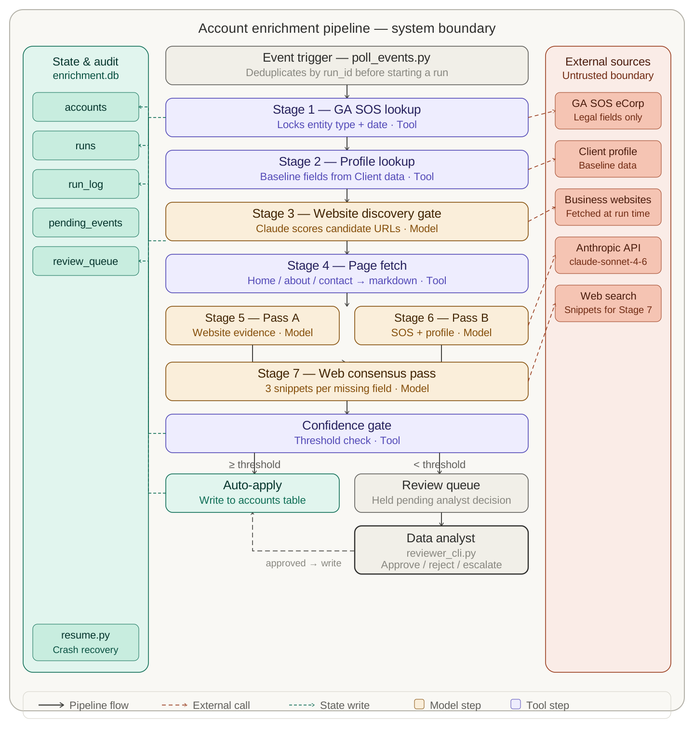
Component | Responsibility | Why needed
Pipeline Orchestrator (pipeline.py) | Runs stages 1–7 in sequence for one account; writes stage checkpoints to SQLite after each stage; handles failure and resume | Coordinates all stages; enables interruption-and-resume
GA SOS Resolver (Stage 1) | HTTP query to Georgia eCorp registry; locks entity type and date established | Only authoritative source for legal fields; must not be overridden by a model
Profile Lookup (Stage 2) | Reads Client profile data for available fields | Baseline structured data; cheapest source
Website Discovery Gate (Stage 3) | Calls Claude to score candidate URLs | Identifies the best evidence source before fetching
Page Fetcher (Stage 4) | Fetches up to 4 pages; strips HTML; truncates to 4000 tokens | Provides grounded evidence for Claude extraction passes
Claude Extraction Passes (Stages 5, 6) | Two scoped Claude calls: website evidence only, then SOS and profile only | Targeted extraction reduces hallucination risk and cost
Web Consensus Pass (Stage 7) | Claude reads 3 web snippets per missing field | Last-resort source for phone, email, address
Confidence Gate | Compares per-field confidence to threshold; auto-applies or routes to review queue | Deterministic quality control; keeps model decisions out of writes
Review Queue (review_queue table) | Holds below-threshold field candidates with evidence until reviewer decides | Durable; survives process restarts
Reviewer CLI (reviewer_cli.py) | Shows analyst proposed value, source, confidence, evidence; records decision | Human oversight for uncertain values
Run State and Audit Log (enrichment.db) | SQLite: accounts, runs, run_log, pending_events, review_queue | Single durable store; enables resume, audit, and reporting
Event Trigger (poll_events.py) | Polls pending_events table; starts pipeline runs; deduplicates by run_id | Decouples request submission from execution
Model strategy. Claude (claude-sonnet-4-6) is called via the Anthropic API for Stages 3, 5, 6, and 7. Each call uses a scoped prompt with explicit no-invent instructions and returns structured JSON with per-field confidence scores and evidence quotes. The model runs remotely (Anthropic-hosted); no local GPU is required.
Retrieval strategy. This pipeline does not use a vector database or RAG. Evidence is fetched directly from primary sources (SOS registry, business websites, web search) at run time and passed as context in the prompt. This is appropriate because the evidence is account-specific and changes with each run; a static knowledge base would not help.
Trust boundaries. Untrusted content enters the system at two points: fetched web page content (Stage 4) and web search snippets (Stage 7). Both are treated as evidence to extract from, never as instructions. The Anthropic API response is validated for schema compliance before any field value is used. The GA SOS result is treated as authoritative but its HTTP response is still parsed defensively. The analyst's review decision is the only human action that authorizes a field write.

5. Data and Feasibility
Data sources. The pipeline draws from four sources in priority order. The Georgia Secretary of State eCorp public registry (ecorp.sos.ga.gov) is a free, public government database; no licensing restrictions apply. The Client's internal business profile data is provided directly for the pilot; it is treated as confidential and not retained beyond the enrichment run. Business websites are publicly accessible; content is fetched at run time and used only for extraction, not stored beyond the evidence excerpt logged per field. Web search snippets are from public web results; again used only for extraction.
The 50-account Athens pilot dataset (Input example.xlsx) is provided by the Client as de-identified business records. It contains no personal data beyond business contact information that is publicly listed.
Tools, libraries, and platforms. Python 3.11 locally. Anthropic SDK for Claude API calls. requests and beautifulsoup4 for HTTP and HTML parsing. openpyxl for xlsx import. sqlite3 (stdlib) for the database. pytest for the test suite. rich for the reviewer CLI. No cloud infrastructure. No GPU. No orchestration framework.
Biggest feasibility risk. Business websites vary enormously in structure and quality. Some will block automated fetches, return mostly JavaScript, or have no contact or about page. This means Pass A may return null for many fields even when the information exists. The fallback is Pass B (SOS and profile data) followed by the web consensus pass, which does not depend on fetching the business's own website. For accounts where all three passes return null for a field, the field remains blank and is flagged for manual enrichment. The system does not fail; it degrades gracefully per field.

6. Initial Design Decision Records
Decision | Rationale | Alternative | Trade-off | Evidence
Use Claude (claude-sonnet-4-6) via Anthropic API for all extraction passes | Extracting structured fields from unstructured web content requires reading comprehension that rules cannot provide. Claude returns structured JSON with confidence scores and evidence quotes in a single call. | GPT-4o via OpenAI API | GPT-4o has similar capability but requires a different SDK and pricing structure. Claude's structured output and per-field confidence scoring fit this pipeline's review-queue design directly. | To be measured in Milestone 2: field extraction accuracy and confidence calibration on the Athens cohort
SQLite as the sole data store for accounts, pipeline state, and audit log | The pilot has 50 accounts and runs locally. SQLite requires no infrastructure, survives process crashes, is queryable, and keeps the project self-contained. | PostgreSQL or a hosted database | A hosted DB adds infrastructure complexity and cost with no benefit at pilot scale. SQLite cannot support concurrent writers, which is not a constraint for a single-analyst local pipeline. | Direct implementation: all five tables (accounts, runs, run_log, pending_events, review_queue) confirmed functional in a local test
Lock legal fields (entity type, date established) from the SOS result — no model can overwrite them | These fields have a single authoritative source (the government registry). Allowing a model to overwrite them introduces hallucination risk for the fields most likely to cause downstream vetting errors. | Let all fields be overwritable by the highest-confidence source | A model might return a more complete or plausible-sounding value for entity type, but the SOS result is the legally correct one. The trade-off is that if the SOS result is wrong or stale, there is no automated correction path. | Requirement from the Client: legal registration status must come from the registry, not inference

7. Individual Plan
This is a solo project. I am the sole contributor across all roles: pipeline design, implementation, testing, evaluation, and documentation.
Collaboration method. Code is tracked in a personal GitHub repository. Tasks are managed with a simple markdown checklist per milestone. No team meetings required.
AI-use disclosure. Claude (claude-sonnet-4-6 via claude.ai) was used to assist with drafting this document, structuring the section narrative, and reviewing the design decision table for completeness. All design decisions, component descriptions, and architecture choices reflect my own analysis of the project requirements and the client context. Document content was reviewed and edited by me before submission to ensure accuracy and alignment with the actual system design. No AI tool was used to fabricate data, invent metrics, or generate diagrams.

